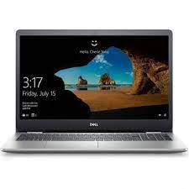

Dell Inspiron I7

* 11th Generation Core™ I7
* 8GB DDR4, 512GB M.2
* 2GB Graphics Memory
* 15.6-Inch FHD Anti-Glare
* **Rs.157,900**